A
CAPSTONE (Major) Project Report
on
E-Credit Note
System
at
Larsen & Toubro Limited



Submitted by
Karan Mittal
Registration Number – 17MCA10050

Guided by
Mr. Surajit Saha Dr. Kanchan Lata Kashyap
Sr. Deputy General Manager Assistant Professor (Sr.)
Larsen & Toubro SSC IT VIT Bhopal University
(External Guide) (Internal Guide)

Submitted in partial fulfillment of the requirement for
The degree of
“Master of Computer Applications”

Submitted to
School of Computing Science and Engineering
VIT Bhopal University
Bhopal (MP) – 466 114

March 2019

VIT BHOPAL UNIVERSITY, M P – 466114

SCHOOL OF COMPUTING SCIENCE AND ENGINEERING

CANDIDATE’S DECLARATION

I hereby declare that the Dissertation entitled “E-Credit Note" is my own work conducted under the supervision of Dr. Kanchan Lata Kashyap, Assistant Professor, School of Computing Science and Engineering at VIT University, Bhopal.
I further declare that to the best of my knowledge this report does not contain any part of work that has been submitted for the award of any degree either in this university or in other university / Deemed University without proper citation.

Karan Mittal
(17MCA10050)
This is to certify that the above statement made by the candidate is correct to the best of my knowledge.
Date:_______________

Internal Guide Name External Guide Name
Dr. Kanchan Lata Kashyap Mr. Surajit Saha
Designation: - Assistant Professor (Sr.) Sr. Deputy General Manager

VIT UNIVERSITY BHOPAL, M P – 466114
SCHOOL OF COMPUTING SCIENCE AND ENGINEERING
CERTIFICATE
This is to certify that the work embodied in this Capstone Project Report entitled “E-Credit Note” has been satisfactorily completed by Karan Mittal Registration No 17MCA10050 in the School Computing Science and Engineering at VIT University, Bhopal. This work is a bonafide piece of work, carried out under my/our guidance in the Organization “Larsen & Toubro Limited” for the partial fulfillment of the degree of Master of Computer Application.

Internal Guide
Dr. Kanchan Lata Kashyap
Assistant Professor(Sr.)
VIT Bhopal University

Forwarded by Approved by
Dr. Baseera Dr Raju Shanmugam
Program Chair Professor & Dean(SCSE)
VIT Bhopal University VIT Bhopal University
ACKNOWLEDGEMENT
The internship opportunity I had with Larsen & Toubro Limited was a great chance for learning and professional development. Therefore, I consider myself as a very lucky individual as I was provided with an opportunity to be a part of it. I am also grateful for having a chance to meet so many wonderful people and professionals who led me though this internship period.
I am using this opportunity to express my deepest gratitude and special thanks to the Mr. Deepak Oak and Mr. Tejas Kashid at L&T SSC Pune who in spite of being extraordinarily busy with their duties, took time out to hear, guide and keep me on the correct path and allowing me to carry out my project at their esteemed organization and extending during the training.
The satisfaction and euphoria that accompanies the successful completion of any task would be incomplete without the mention of the people who made it possible. If there is a Driving force that kept use going on in doing this project, it is the constant support of my internal guide Dr. Kanchan Lata Kashyap I present my sincere and heartiest thanks to him, for giving me a patient hearing and clearing m doubts.
I would like to express my profound thanks to Dr. S Raju (Dean of SCSE) for their Support and encouragement towards me at every stage in successful completion of my project and my Degree.

Karan Mittal
(17MCA10050)

ABSTRACT
L&T does not sell the parts directly to the customers instead L&T sells it through the dealer. According to the L&T Product policy if the product is idle or non-movable, at the end of the year L&T takes it back to the central warehouse (Nagpur) after verifying the products/goods if it is in reusable condition or not. After the acceptance of the goods/products all the reports and documents are forwarded to the central warehouse including challan, here at central warehouse the goods/parts and documents/reports are re-verified and a GRN (goods report note) is prepared and also confirming that CWH has received all the documents and are correct through a checkbox. And after from the central warehouse the documents including the GRN is forwarded to the L&T Pune SSC. After updating in the L&T SSC Pune the Information are moved to the archival.
The purpose of this project is to digitalize the manual work of the Credit Note request processing, which will reduce manual documentation save the time to process the request. It will also reduce the paper work. Which will result in the faster processing of the credit notes and efficient handling of the requests.

TABLE OF CONTENTS
Inner first page…………………………………………………………..(i)
Declaration…...………………………………………………………….(ii)
Certificate……..…….…………………………………………………...(iii)
Acknowledgement…………………...…………………………………..(iv)
Abstract…………………...……………………………………………...(v)
Table of Contents……………………...…………………………………(vi)
CHAPTER 1 1
INTRODUCTION 1
1.1. Objective 1
1.2. Proposed system 3
1.3 PROFILE OF THE PROBLEM. RATIONALE/SCOPE OF THE STUDY 3
CHAPTER - 2 4
ORGANIZATION PROFILE 4
CHAPTER - 3 7
PROBLEM ANALYSIS 7
3.1. Product definition 7
3.2. Feasibility analysis 7
3.2.1. Technical feasibility 7
3.2.2. Financial feasibility 7
CHAPTER - 4 8
SOFTWARE REQUIREMENT ANALYSIS 8
4.1. TECHNOLOGIES 8
4.1.1. ASP.NET 8
4.1.2. ADO.NET 9
4.1.2.1. The Data Adapter Object 10
4.1.2.2. The DataReader Object 11
4.1.4. HTML 12
4.1.5. CSS 12
4.2. TOOLS USED 13
4.2.1. Eclipse 13
4.2.2. Visual studio 13
4.2.3. MS-SQL DATABASE 14
CHAPTER - 5 15
DESIGN 15
5.1. Workflow diagram 15
5.2. DATABASE DESIGN 18
5.2.1. Customer Master 18
5.2.2. E_Req_Route 18
5.2.3. ReqStatus 19
5.2.4. Reqcount 20
5.2.5. Pdetails 20
5.2.6. Pdetails 21
5.2.7. Audit Trial 21
5.2.8. Temporary 22
5.3. DATA FLOW DIAGRAM 22
5.3.1. Zero level 22
5.3.2. First Level DFD 23
CHAPTER – 6 26
IMPLEMENTATION 26
6.1. PROCESS MODEL USED: Spiral model 26
6.2. Conversion Plan 26
6.3. Post implementation of project and maintenance 27
CHAPTER – 7 28
SYSTEM TESTING 28
7.1. Testing strategies 28
7.1.1. Unit testing 28
7.1.2. Integration testing 29
7.1.3. System testing 29
7.1.4. Acceptance testing 29
7.2. Testing methods 30
7.2.1. White box testing 30
7.2.2. Black box testing 30
7.3. Validation 30
7.4. Limitations 30
7.5. Test results 31
7.6. DEMONSTRATION/SCREENSHOTS 32
CHAPTER – 8 40
CONCLUSION 40
8.1. Current state of project 40
8.2. Remaining areas of concern 40
8.3. Technical and managerial lessons learnt 40
8.4. Future scope 40
Bibliography 41
Reference 41

CHAPTER 1

INTRODUCTION

L&T does not sell the parts directly to the customers instead L&T sells it through the dealer. According to the L&T Product policy if the product is idle or non-movable, at the end of the year L&T takes it back to the central warehouse (Nagpur) after verifying the products/goods if it is in reusable condition or not. After the acceptance of the goods/products all the reports and documents are forwarded to the central warehouse including challan, here at central warehouse the goods/parts and documents/reports are re-verified and a GRN (goods report note) is prepared and also confirming that CWH has received all the documents and are correct through a checkbox. And after from the central warehouse the documents including the GRN is forwarded to the L&T Pune SSC. After updating in the L&T Pune SSC the Information are moved to the archival.
The purpose of this project is to digitalize the manual work of the Credit Note request processing, which will reduce manual documentation save the time to process the request. It will also reduce the paper work. This will result in the faster processing of the credit notes and efficient handling of the requests.

1.1. Objective
Below are the objectives that shall be fulfilled post the execution of this project:

Dealer/Customer
• Access to dealer home page
• Create new request
• Edit Profile
• Has option of save as draft to complete the incomplete request later.
• Can view the request status

Local representative
• Access to local representative home page.
• Can view requests full details of the dealer of same location in between two dates.
• Can forward the request and send back the request to the customer with remark.
• Also can reject the request at certain conditions.

Location head/Approver
• Access to Approver home page.
• Can view requests of same location, which has been forwarded by the checker.
• Can forward the request and send back the request to the customer with remark.
• Can see the checker remark also.
• Also can reject the request at certain conditions.

CWH (central warehouse)
• Access to its home page.
• Can view requests from the all part of india,which has been approved by the approver.
• Will re-verify all product and related request notes/documents.
• Can see the checker and approver remark also.
• Also can reject the request at certain conditions.
• After verifying cwh will generate a GRN and forward it to L&T Pune SSC.

L&T Pune SSC
• Access to its home page.
• will scan and store all the documents is being forwarded by the CWH..
• After some time documents will be moved to the archival.

1.2. Proposed system
This Project is aimed at:
- This system is designed to provide automation support for the process of E-credit system.
- The system will allow dealer to fill online form and provide all the necessary data like Item no, invoice no, Quantity, rate, amount within built calculations. It will provide a single platform to process the request and forwarding to the next level for approval and faster processing.
- It will provide option for uploading all desired/mandatory documents at different steps (wherever required) and will be available for the view and downloading at Warehouse and SSC Pune.

. PROFILE OF THE PROBLEM. RATIONALE/SCOPE OF THE STUDY
Through proven experience from successful organizations of all sizes, a strong program of policy and procedure management is much more than a necessary evil to have in place in case something goes wrong. Individual policy and procedure documents are the critical framework upon which an organization’s compliance effectiveness and operational success are built. An organization’s policies provide the basic rules, direction and definitions that not only protect a company, but also provide formulas for profitability and productivity. If an organization’s policies and critical procedures are not managed properly, time is wasted, money is lost and risk exposure is elevated.

The solution developed will address the objective in a holistic manner and will have all the features and functionalities which shall let the portal allow a user to keep a record of his policies and buy new policies and admin to add new policies along with other features such as edit and search.

CHAPTER - 2

ORGANIZATION PROFILE

Larsen & Toubro is a US$14.3 billion technology, engineering, construction and manufacturing and financial services conglomerate. It addresses critical needs in key sectors including infrastructure, construction, hydrocarbon, power, defense and aerospace. Its footprint extends across seven countries in addition to India. A strong, customer-focused approach, conformance to global HSE standards and the constant quest for top-class quality have enabled the Company to sustain leadership in its major lines of business for over 75 years. L&T was rated 58th Most Innovative Company by Forbes International and fourth in the global list of ‘green companies’ in the industrial sector by Newsweek. It was voted among the most admired companies in the country by Fortune India, and rated eighth Most Powerful Brand in India by Brand Finance. It won The Economic Times Corporate Citizen of the Year Award - 2013, instituted by one of the world’s most widely sold business newspapers - The Economic Times. A survey by a leading HR consultancy affirmed its reputation as a people-focused company, leading to the award for the ‘Most Attractive Employer’ in the industrial sector.
History
The evolution of L&T into a major engineering and construction organization is among the more remarkable success stories in Indian industry. It was founded in Mumbai (then Bombay) in 1938 by two Danish engineers, Henning Holck-Larsen and Soren Kristian Toubro. Beginning with the import of machinery from Europe, L&T took on engineering and construction assignments of increasing sophistication. Today, the company sets engineering benchmarks in terms of scale and complexity.
Corporate Sustainability
L&T was the first company in India in the engineering & construction space to publicly disclose its sustainability performance. The Company’s annual Sustainability Reports highlight achievements and objectives across the traditional three ‘Ps’ of Planet, People and Profits. All our Reports are rated A+ by Global Reporting Initiatives, indicating the highest level of disclosure. The recognition that the Company has secured from forums around the world affirm public perception of L&T as an organization that contributes significantly to the wellbeing of people.
Record of Achievements
- Technological support in the launch and tracking systems for Mangalyaan – India’s Mars Mission, and the only mission to successfully enter Martian orbit in its maiden attempt. Earlier L&T had also contributed to India’s lunar mission.
- Metro projects being executed in Riyadh and Qatar as part of international consortiums.
- Engaged in building major new airports in Delhi, Mumbai, Bangalore, Hyderabad and internationally, in Sharjah, Oman.
- Mass Rapid Transit Systems including India’s first monorail in Mumbai, and critical sections of metro systems in New Delhi, Hyderabad, Bangalore, Chennai, Kolkata, Kochi, Lucknow.
- Building major infrastructure projects including ports, specialized bridges and highway projects.
- Building of INS Arihant – India’s first nuclear powered submarine.
- The world's largest coal gasifier made in India and exported to China.
- The world’s biggest EO reactor for a petrochemical complex in the Gulf
- The world’s largest FCC regenerator for a refinery.
- Design & manufacture of a wide range of switchgear products and systems exported to over 30 countries.

Information Technology
Larsen & Toubro InfoTech, a 100% subsidiary of L&T, offers comprehensive, end-to-end software solutions and services with a focus on Manufacturing, BFSI and Communications & Embedded Systems. It provides a cost cutting partnership in the realm of offshore outsourcing, application integration and package implementation. Leveraging the heritage and domain expertise of the parent company, its services encompass a broad technology spectrum, catering to leading international companies across the globe.

CHAPTER - 3

PROBLEM ANALYSIS

3.1. Product definition

The purpose of this project is to digitalize the manual work of the Credit Note request processing, which will reduce manual documentation and save the time to process the request. It will also reduce the paper work. Which will result in the faster processing of the credit notes and efficient handling of the requests.

3.2. Feasibility analysis
A feasibility study is an analysis used in measuring the ability and likelihood to complete a project successfully including all relevant factors. It must account for factors that affect it such as economic, technological, legal and scheduling factors. Project managers use feasibility studies to determine potential positive and negative outcomes of a project before investing a considerable amount of time and money into it.

3.2.1. Technical feasibility
All the technology’s that are required are open source and are freely available to use like Visual Studio 2012, MS-SQL and JavaScript along with all the learning materials. Eclipse is use as an IDE to develop the project along with C# for dependency injection in the project.

3.2.2. Financial feasibility
All the software used to develop this application is freely available so no cost is spent in the development process. Since the software’s are open source we will get free update and new features in the future for free.

CHAPTER - 4

SOFTWARE REQUIREMENT ANALYSIS

4.1. TECHNOLOGIES

4.1.1. ASP.NET
ASP.NET is a web application framework developed and marketed by Microsoft to allow programmers to build dynamic web sites. It allows you to use a full featured programming language such as C# or VB.NET to build web applications easily.
Understanding the page cycle helps in writing codes for making some specific thing happen at any stage of the page life cycle. It also helps in writing custom controls and initializing them at right time, populate their properties with view-state data and run control behavior code.
Following are the different stages of an ASP.NET page:
- Page request - When ASP.NET gets a page request, it decides whether to parse and compile the page, or there would be a cached version of the page; accordingly the response is sent.
- Starting of page life cycle - At this stage, the Request and Response objects are set. If the request is an old request or post back, the IsPostBack property of the page is set to true. The UICulture property of the page is also set.
- Page initialization - At this stage, the controls on the page are assigned unique ID by setting the UniqueID property and the themes are applied. For a new request, postback data is loaded and the control properties are restored to the view-state values.
- Page load - At this stage, control properties are set using the view state and control state values.
- Validation - Validate method of the validation control is called and on its successful execution, the IsValid property of the page is set to true.
- Postback event handling - If the request is a postback (old request), the related event handler is invoked.
- Page rendering - At this stage, view state for the page and all controls are saved. The page calls the Render method for each control and the output of rendering is
- Unload - The rendered page is sent to the client and page properties, such as written to the OutputStream class of the Response property of page.Response and Request, are unloaded and all cleanup done.

4.1.2. ADO.NET
ADO.NET provides a bridge between the front end controls and the back end database. The ADO.NET objects encapsulate all the data access operations and the controls interact with these objects to display data, thus hiding the details of movement of data.
Data provider is used to connect to the database, execute commands and retrieve the record. It is lightweight component with better performance. It also allows us to place the data into DataSet to use it further in our application.
NET Framework data provider | Description
.NET Framework Data Provider for SQL Server | It provides data access for Microsoft SQL Server. It requires the System.Data.SqlClientnamespace.
.NET Framework Data Provider for OLE DB | It is used to connect with OLE DB. It requires the System.Data.OleDb namespace.
.NET Framework Data Provider for ODBC | It is used to connect to data sources by using ODBC. It requires the System.Data.Odbcnamespace.
.NET Framework Data Provider for Oracle | It is used for Oracle data sources. It uses the System.Data.OracleClient namespace.
EntityClient Provider | It provides data access for Entity Data Model applications. It requires the System.Data.EntityClient namespace.
.NET Framework Data Provider for SQL Server Compact 4.0. | It provides data access for Microsoft SQL Server Compact 4.0. It requires the System.Data.SqlServerCe namespace.
The .NET Framework provides the following data providers that we can use in our 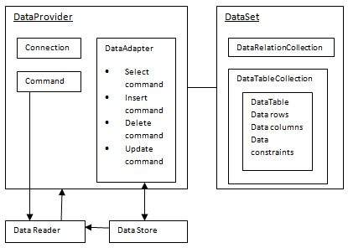

4.1.2.1. The Data Adapter Object
The DataAdapter object acts as a mediator between the DataSet object and the database. This helps the Dataset to contain data from multiple databases or other data source.

4.1.2.2. The DataReader Object
The DataReader object is an alternative to the DataSet and DataAdapter combination. This object provides a connection oriented access to the data records in the database. These objects are suitable for read-only access, such as populating a list and then breaking the connection.
4.1.3. C-SHARP(C#)
C# is a simple, modern, general-purpose, object-oriented programming language developed by Microsoft within its .NET initiative led by Anders Hejlsberg. This tutorial will teach you basic C# programming and will also take you through various advanced concepts related to C# programming language.
C# is a modern, general-purpose, object-oriented programming language developed by Microsoft and approved by European Computer Manufacturers Association (ECMA) and International Standards Organization (ISO).
C# was developed by Anders Hejlsberg and his team during the development of .Net Framework.
C# is designed for Common Language Infrastructure (CLI), which consists of the executable code and runtime environment that allows use of various high-level languages on different computer platforms and architectures.
The following reasons make C# a widely used professional language −
- It is a modern, general-purpose programming language
- It is object oriented.
- It is component oriented.
- It is easy to learn.
- It is a structured language.
- It produces efficient programs.
- It can be compiled on a variety of computer platforms.
- It is a part of .Net Framework.

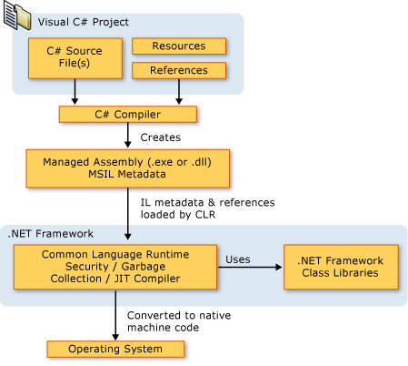
Figure 1: C# Flow in application

4.1.4. HTML
HTML stands for Hypertext Markup Language, and it is the most widely used language to write Web Pages.
- Hypertext refers to the way in which Web pages (HTML documents) are linked together. Thus, the link available on a webpage is called Hypertext.
- As its name suggests, HTML is a Markup Language which means you use HTML to simply "mark-up" a text document with tags that tell a Web browser how to structure it to display.
Originally, HTML was developed with the intent of defining the structure of documents like headings, paragraphs, lists, and so forth to facilitate the sharing of scientific information between researchers.
Now, HTML is being widely used to format web pages with the help of different tags available in HTML language.

4.1.5. CSS
Cascading Style Sheets, fondly referred to as CSS, is a simple design language intended to simplify the process of making web pages presentable.
CSS handles the look and feel part of a web page. Using CSS, you can control the color of the text, the style of fonts, the spacing between paragraphs, how columns are sized and laid out, what background images or colors are used, layout designs,variations in display for different devices and screen sizes as well as a variety of other effects.
CSS is easy to learn and understand but it provides powerful control over the presentation of an HTML document. Most commonly, CSS is combined with the markup languages HTML or XHTML.
- Selector − A selector is an HTML tag at which a style will be applied. This could be any tag like <h1> or <table> etc.
- Property − A property is a type of attribute of HTML tag. Put simply, all the HTML attributes are converted into CSS properties. They could be color, border etc.

4.2. TOOLS USED

4.2.1. Eclipse
Eclipse is an integrated development environment (IDE) used in computer programming, and is the most widely used Asp.net IDE. It contains a base workspace and an extensible plug-in system for customizing the environment. Eclipse is written mostly in Asp.net and its primary use is for developing Asp.net applications.

4.2.2. Visual studio
Visual Studio is a source-code editor developed by Microsoft for Windows, Linux and macOS. It includes support for debugging, embedded Git control, syntax highlighting, intelligent code completion, snippets, and code refactoring. It is also customizable, so users can change the editor's theme, keyboard shortcuts, and preferences. The source code is free and open source and released under the permissive MIT License. The compiled binaries are freeware and free for private or commercial use.

4.2.3. MS-SQL DATABASE
Ms-sql is a fast, easy-to-use RDBMS being used for many small and big businesses. Ms-sql is developed, marketed, and supported by Ms-sql AB, which is a Swedish company. Ms-sql is becoming so popular because of many good reasons:
- Ms-sql is released under an open-source license. So you have nothing to pay to use it.
- Ms-sql is a very powerful program in its own right. It handles a large subset of the functionality of the most expensive and powerful database packages.
- Ms-sql uses a standard form of the well-known SQL data language.
- Ms-sql works on many operating systems and with many languages including PHP, PERL, C, C++, ASP.NET, etc.
- Ms-sql works very quickly and works well even with large data sets.
- Ms-sql is very friendly to PHP, the most appreciated language for web development.
- Ms-sql supports large databases, up to 50 million rows or more in a table. The default file size limit for a table is 4GB, but you can increase this (if your operating system can handle it) to a theoretical limit of 8 million terabytes (TB).
- Ms-sql is customizable. The open-source GPL license allows programmers to modify the Ms-sql software to fit their own specific environments.

CHAPTER - 5

DESIGN

5.1. Workflow diagram
Dealer will fill the request form by providing product details which they are offering to return i.e. Invoice no, product code, quantity and rate. System will have option to calculate credit note request amount automatically. After completion of the form & uploading documents, claim to be submitted on the portal. This step would be called as Initiator Step. Also, Request number would be generated at this step after submission of the claim.
Request will come to the concerned L&T representative for verification/validation of the claim Here L&T representative will have option to reduce the amount if required, however, option for increasing values will not be provided at all, if value required to be increased, it is to be sent back to Dealer for review and modification. After due verification to ensure correctness of the claim, it is to be submitted for approval, by attaching documents (if any) , else request will be send back to the dealer for desired modifications / rectifications. This step would be called as Passed By step.
Concerned authority will verify and approve the request. At this step, approver will not have any option to edit or modify the data / documents provided with the claim, however, he can send the claim back to previous step with remarks / instructions. After approval, claims will move to Warehouse for further processing. In the bottom of the claim form, Initiator & Passed By details would be visible which certifies authenticity of the claim Initiation and due verification.
Warehouse will verify the material with the details provided in the claim and GRN would be prepared after due verification of the material and documents If Warehouse observes any error or discrepancy, claim can be sent back to the Passed By user for correction and justification sought by Warehouse. Once the claim is sent back to Passed By user, again the whole process of submission for approval would be followed.
A checkbox would be provided at the bottom of the form/page along with fields for mandatory details like Date, GRN no etc.) After due verification and uploading desired documents (if any) Warehouse will submit the form to SSC for further processing. Checkbox is a mandatory field that indicates Central Warehouse has received material along with all desired documents / reports and has verified it.
SSC will verify the claim & documents and process the credit note in SAP. At this step, SSC can download data / documents (if desired). After completion of process, SSC will upload scan copy of Credit Note for record purpose.

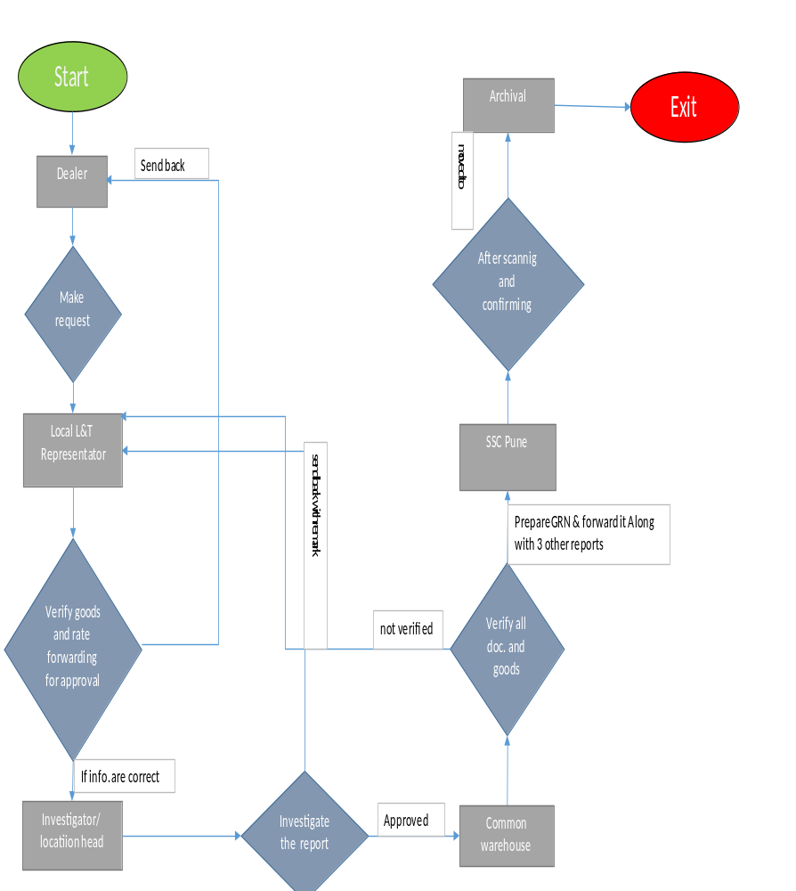
Figure 2: Workflow Diagram

5.2. DATABASE DESIGN

5.2.1. Customer Master
Column Name | Data Type | Allow Null
Role | Nvarchar(50) | yes
Last Updated | Datetime | Yes
Name | Nvarchar(50) | Yes
User ID | Nvarchar(50) | Yes
Email | Nvarchar(50) | Yes
Address | Nvarchar(50) | Yes
Location | Nvarchar(50) | Yes
Password | Nvarchar(50) | Yes
Registered Date | Datetime | yes

5.2.2. E_Req_Route
Column Name | Data Type | Allow Null
Id | int | No
Req_no | Nvarchar(50) | Yes
Customer_Name | Nvarchar(50) | Yes
Customer_Code | Nvarchar(50) | Yes
Req_date | datetime | Yes
Req_Location | Nvarchar(20) | Yes
ModifiedBy | Nvarchar(50) | Yes
ModifiedDate | datetime | Yes
StatusFlag | int | Yes
VeryfiedBy | Nvarchar(50) | Yes
Veryfied_Date | datetime | Yes
Verified_remark | Nvarchar(Max) | Yes
Sendback_remarks | Nvarchar(Max) | Yes
Sendback_Date | datetime | Yes
ApprovedBy | Nvarchar(50) | Yes
ApprovedDate | datetime | Yes
ApproverVerified_Remarks | Nvarchar(Max) | Yes
ApproverSendback_Date | datetime | Yes
ApproverSendback_Remark | Nvarchar(Max) | Yes
CWH_VerifiedDate | datetime | Yes
CWH_RejectDate | datetime | Yes
CWH_Rejectremarks | Nvarchar(50) | Yes
CWH_GRNrepDate | datetime | Yes
ScanningDate | datetime | Yes

5.2.3. ReqStatus
Column Name | Data Type | Allow Null
StatusId | Int | No
Status_Description | Nvarchar(50) | Yes
ReqStatus | int | Yes

5.2.4. Reqcount
Column Name | Data Type | Allow Null
ID | int | No
Reqcount | int | Yes
Financial_year | Char(4) | Yes

5.2.5. Pdetails
Column Name | Data Type | Allow Null
ID | int | No
Customer_ID | Nvarchar(50) | Yes
Product_Code | Nvarchar(50) | Yes
Description | Nvarchar(max) | Yes
Invoice_No | Nvarchar(50) | Yes
Qty | Nvarchar(50) | Yes
Rate | Nvarchar(50) | Yes
Amount | Nvarchar(50) | Yes
Invoice | Nvarchar(50) | Yes
Reqno | Nvarchar(50) | Yes

5.2.6. Pdetails
Field Name | Field Type | Mandatory
Request NO. | nvarchar(50) | yes
Staus | nvarchar(50) | yes
Remarks | nvarchar(150) | yes
Action_on | Datetime | yes

5.2.7. Audit Trial

Field Name | Field Type | Mandatory
Request NO | nvarchar(50) | yes
Action_is | nvarchar(50) | yes
Action_By | nvarchar(50) | yes
Remarks | nvarchar(150) | yes
Action | Datetime | Yes

5.2.8. Temporary
Field Name | Field Type | Mandatory
ID | int | Yes
Customer_ID | nvarchar(50) | Yes
Product_Code | nvarchar(50) | Yes
Discription | nvarchar(50) | Yes
Invoice No. | nvarchar(50) | Yes
Quantity | int | Yes
Rate | Decimal(18,2) | Yes
Amount | Decimal(18,2) | Yes
Invoice | nvarchar(50) | Yes
Request_Date | nvarchar(50) | yes

5.3. DATA FLOW DIAGRAM

5.3.1. Zero level
DFD Level 0 is also called a Context Diagram. It’s a basic overview of the whole system or process being analyzed or modeled. It’s designed to be an at-a-glance view, showing the system as a single high-level process, with its relationship to external entities. It should be easily understood by a wide audience, including stakeholders, business analysts, data analysts and developers.
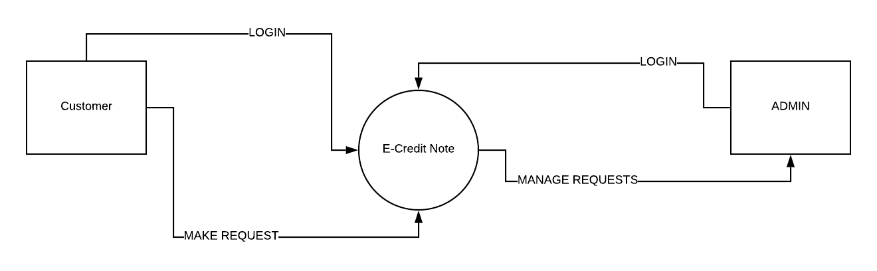

Figure 3: Zero Level DFD

5.3.2. First Level DFD
The Level 0 DFD is broken down into more specific, Level 1 DFD. Level 1 DFD depicts basic modules in the system and flow of data among various modules. Level 1 DFD also mentions basic processes and sources of information.
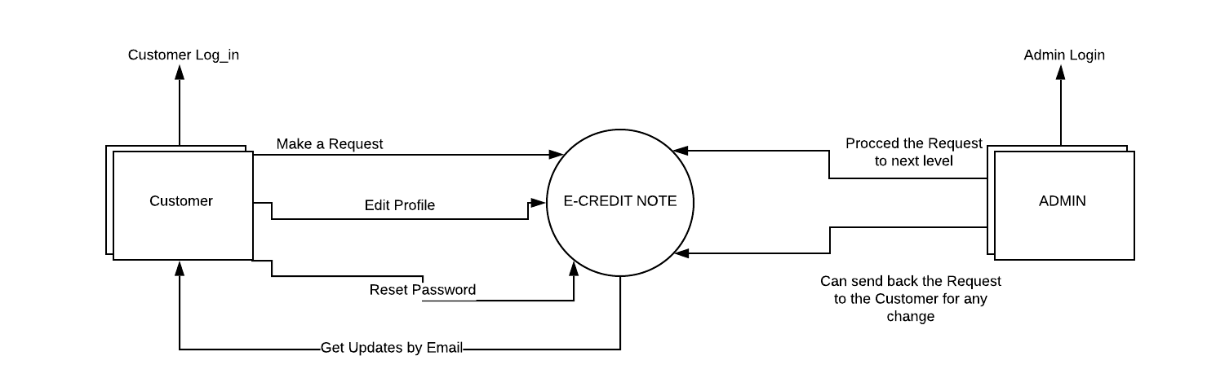
Figure 4:First level DFD

5.4. USE CASE DIAGRAM
Customer will fill the request form by providing product details which they are offering to return i.e. Invoice no, product code, quantity and rate. System will have option to calculate credit note request amount automatically. After completion of the form & uploading documents, claim to be submitted on the portal. This step would be called as Initiator Step. Also, Request number would be generated at this step after submission of the claim.
Request will come to the concerned L&T representative for verification/validation of the claim Here L&T representative will have option to reduce the amount if required, however, option for increasing values will not be provided at all, if value required to be increased, it is to be sent back to Dealer for review and modification. After due verification to ensure correctness of the claim, it is to be submitted for approval, by attaching documents (if any) , else request will be send back to the dealer for desired modifications / rectifications. This step would be called as Passed By step.
Concerned authority will verify and approve the request. At this step, approver will not have any option to edit or modify the data / documents provided with the claim, however, he can send the claim back to previous step with remarks / instructions. After approval, claims will move to Warehouse for further processing. In the bottom of the claim form, Initiator & Passed By details would be visible which certifies authenticity of the claim Initiation and due verification.
Warehouse will verify the material with the details provided in the claim and GRN would be prepared after due verification of the material and documents If Warehouse observes any error or discrepancy, claim can be sent back to the Passed By user for correction and justification sought by Warehouse. Once the claim is sent back to Passed By user, again the whole process of submission for approval would be followed.
A checkbox would be provided at the bottom of the form/page along with fields for mandatory details like Date, GRN no etc.) After due verification and uploading desired documents (if any) Warehouse will submit the form to SSC for further processing. Checkbox is a mandatory field that indicates Central Warehouse has received material along with all desired documents / reports and has verified it.
SSC will verify the claim & documents and process the credit note in SAP. At this step, SSC can download data / documents (if desired). After completion of process, SSC will upload scan copy of Credit Note for record purpose.

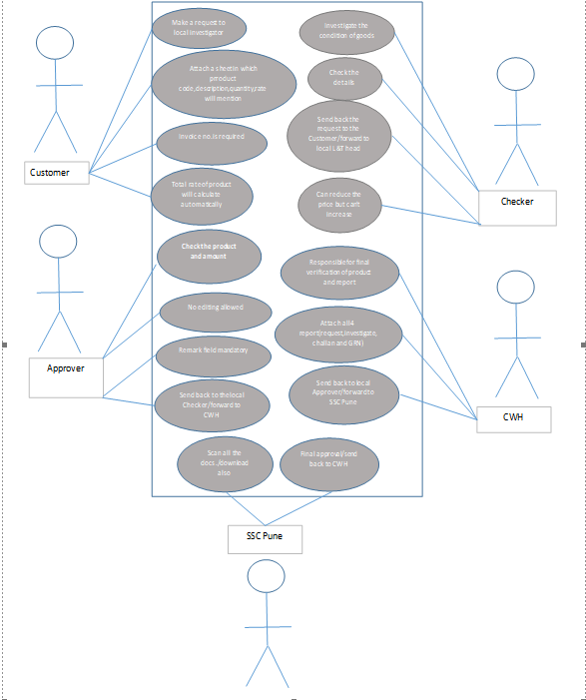
Figure 5: User use case

CHAPTER – 6

IMPLEMENTATION

6.1. PROCESS MODEL USED: Spiral model
The Spiral model originally proposed, is an evolutionary software process model that couples the iterative nature of prototyping with the controlled & systematic aspects of the linear sequential model. It provides the potential for rapid development of incremental version of the software.
Using the spiral model software is developed in a series of incremental releases. A spiral model is divided into a number of framework activities also called task regions.
A spiral model contains six task regions:
- Customer Communication: Tasks required to establish effective communication
between developer & customer.
- Planning: Tasks required to define resources, timeline & timeline & another project related information.
- Risk analysis: Task required to access.
- Engineering: Tasks required to build one or more representation of the application.
- Construction & release: Task required to construct, test, install & provide user support (e.g., documentation & Training)
Customer evaluation: Tasks required to obtain customer feedback based on evolution of the software representation created during the engineering stage & implemented during the installation stage.

6.2. Conversion Plan
To make this project live, i.e., to build application file for the project followed:
- Installation of Visual Studio.
- Select a server at which you will host your web application.
- Once Visual studio is set, you need to create a new project and select the suitable web-app.
- Select the Database which will serve the purpose of the application accordingly.
- We need to give the right to the admin who could change the database table and details.
- After all the business logic Is successfully written and implemented. The project is live!

6.3. Post implementation of project and maintenance
The Post Implementation Review (PIR) is conducted after a project has been completed. The purpose of the PIR is to evaluate how successfully the project objectives have been met and how effective the project management practices were in keeping the project on track.
In our project the all objectives met to the requirements and it is more affective as user wants. According to the user requirements the project functionality and objectives are made according to this. It is generally found that systems that are easy to use, require less manpower, saves the data entry and well received by people.

CHAPTER – 7

SYSTEM TESTING

Testing is the process of evaluating a system or its components with the intent to find that whether it satisfies the specified requirements or not. This activity results in the actual, expected and difference between their results i.e. testing is executing a system in order to identify any gaps, errors or missing requirements in contrary to the actual desire or requirements.

7.1. Testing strategies
In order to make sure that system does not have any errors, the different levels of testing strategies that are applied at different phases of software development are

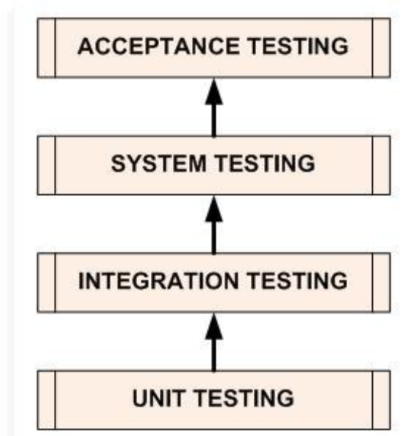
Figure 6: Testing Strategies

7.1.1. Unit testing
The goal of unit testing is to isolate each part of the program and show that individual parts are correct in terms of requirements and functionality.

7.1.2. Integration testing
The testing of combined parts of an application to determine if they function correctly together is Integration testing. This testing can be done by using two different methods.

7.1.2.1. Top down integration testing
In Top-Down integration testing, the highest-level modules are tested first and then progressively lower-level modules are tested.

7.1.2.2. Bottom-up integration testing
Testing can be performed starting from smallest and lowest level modules and proceeding one at a time. When bottom level modules are tested attention turns to those on the next level that use the lower level ones they are tested individually and then linked with the previously examined lower level modules. In a comprehensive software development environment, bottom-up testing is usually done first, followed by top-down testing.

7.1.3. System testing
This is the next level in the testing and tests the system as a whole. Once all the components are integrated, the application as a whole is tested rigorously to see that it meets Quality Standards. 30

7.1.4. Acceptance testing
The main purpose of this Testing is to find whether application meets the intended specifications and satisfies the client’s requirements. We will follow two different methods in this testing.

7.1.4.1. Alpha testing
This test is the first stage of testing and will be performed amongst the teams. Unit testing, integration testing and system testing when combined are known as alpha testing. During this phase, the following will be tested in the application:
- Broken Links.
- The Application will be tested on machines with the lowest specification to test loading times and any latency problems.

7.1.4.2. Beta testing
In beta testing, a sample of the intended audience tests the application and send their feedback to the project team. Getting the feedback, the project team can fix the problems before releasing the software to the actual users.

7.2. Testing methods

7.2.1. White box testing
White box testing is the detailed investigation of internal logic and structure of the Code. To perform white box testing on an application, the tester needs to possess knowledge of the internal working of the code. The tester needs to have a look inside the source code and find out which unit/chunk of the code is behaving inappropriately.

7.2.2. Black box testing
The technique of testing without having any knowledge of the interior workings of the application is Black Box testing. The tester is oblivious to the system architecture and does not have access to the source code. Typically, when performing a black box test, a tester will interact with the system’s user interface by providing inputs and examining outputs without knowing how and where the inputs are worked upon.

7.3. Validation
All the levels in the testing (unit integration, system) and methods (black box, white box) are implemented on our application successfully and the results obtained as expected.

7.4. Limitations
The execution time for support vector machine is more so that the user may not receive the result fast.

7.5. Test results
The testing is done among the team members and by the end users. It satisfies the specified requirements and finally we obtained the results as expected.

TC01 | On register page enter valid name, email, customer ID, location, mobile and matching password. | The name must follow the pattern specified (no alphanumeric string), and email should end with “@something”. Mobile number should be exactly 10 characters | After the validation is all successful, the actor would be forwarded to the log in page | Pass
TC02 | On login page Enter valid Username and  Password. Then submit. | The credentials should match with database. Otherwise it will give error message. | After matching username and password it will forward it to the Request Page. | Pass
TC03 | On the Request page customer’s details will auto fetch from the database and can fill the form by manually or by exel sheet. customer can view final attachments before final submission | Total amount is calculated based on formula which uses number of parts, estimated price of one part. | In any case customer can save the form in draft for later submission. | Pass

7.6. DEMONSTRATION/SCREENSHOTS

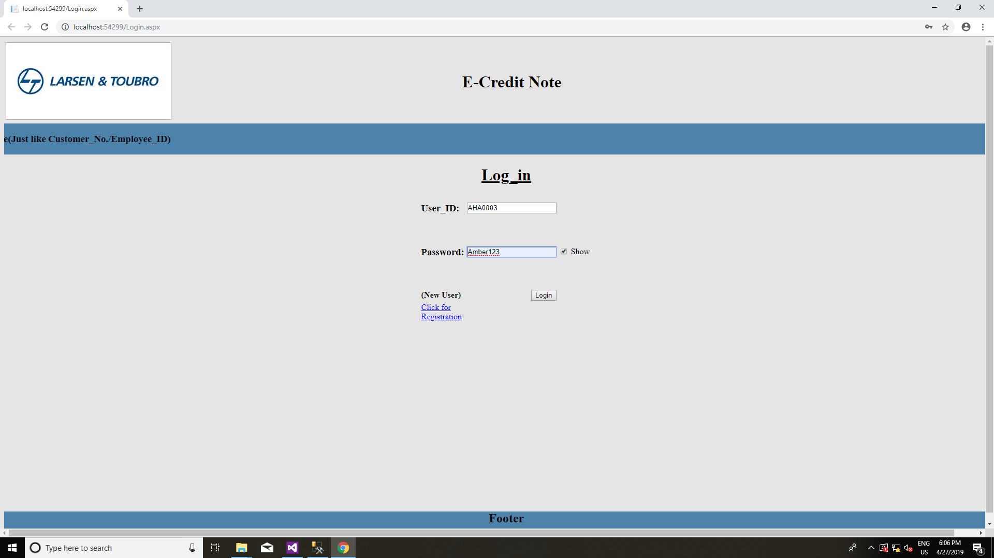
Figure 7: User Login Page

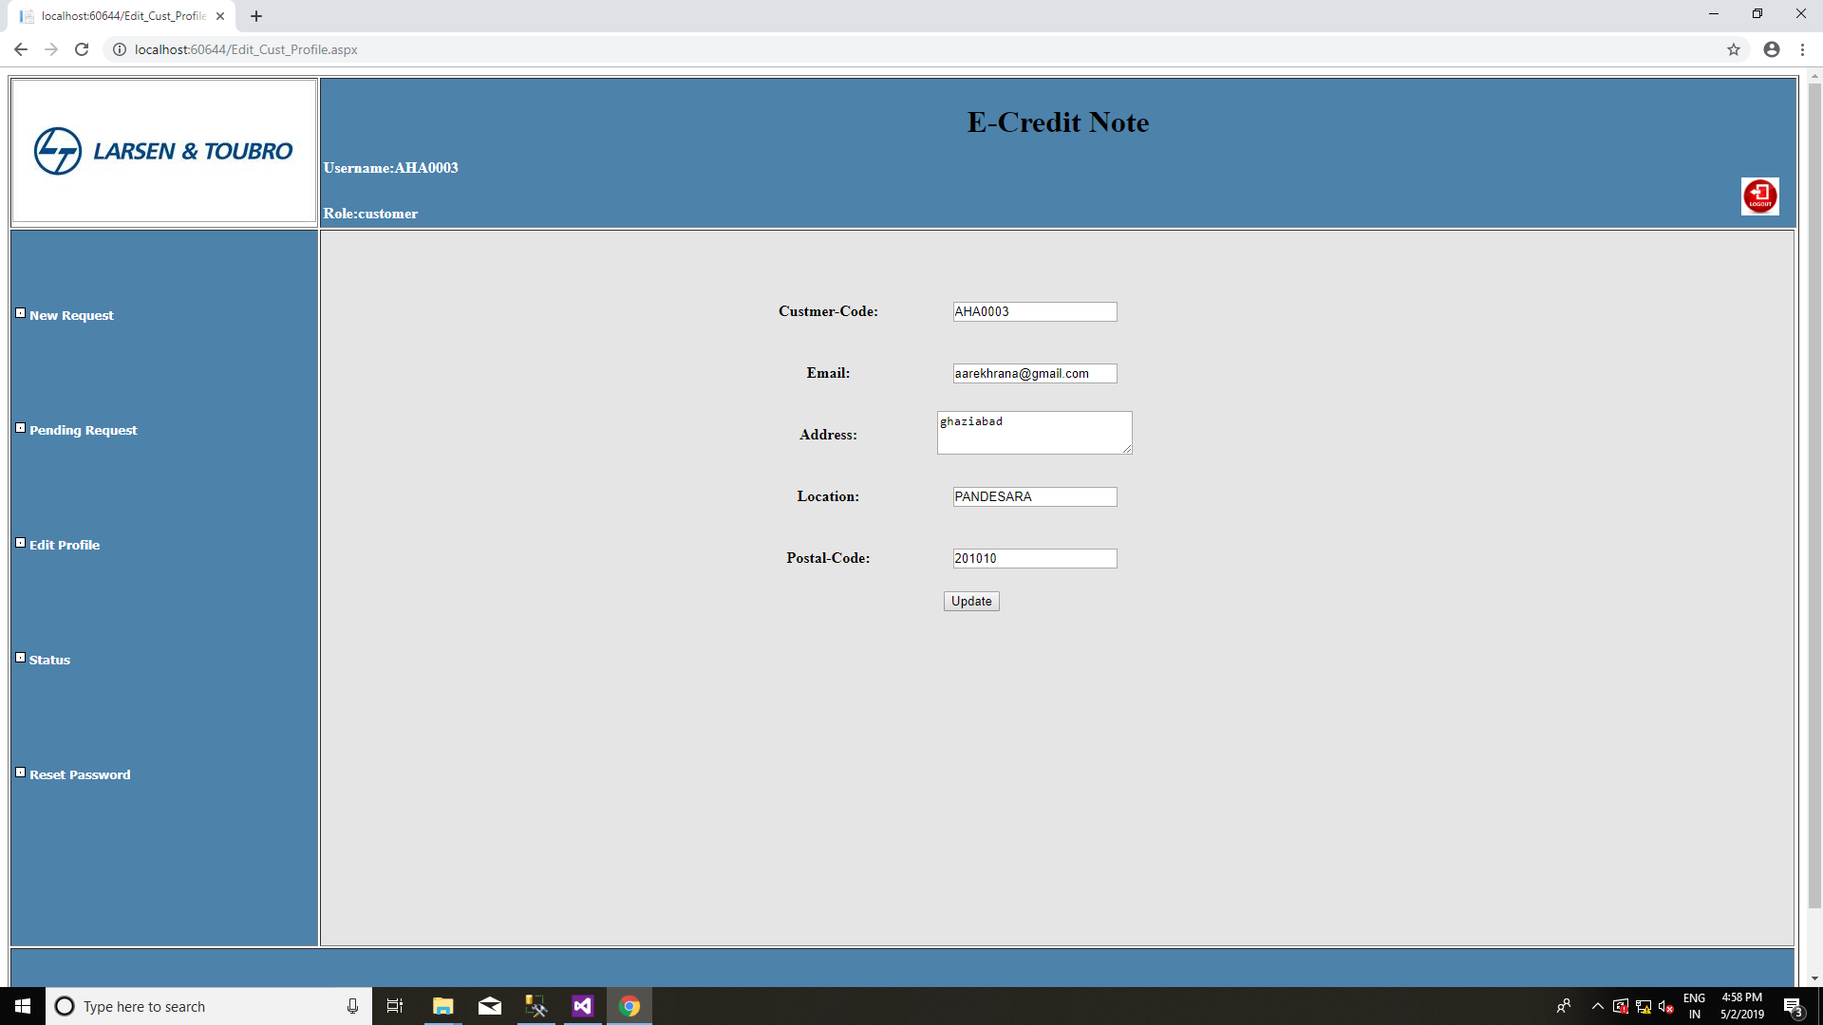
Figure 8 : Customer can edit their profile
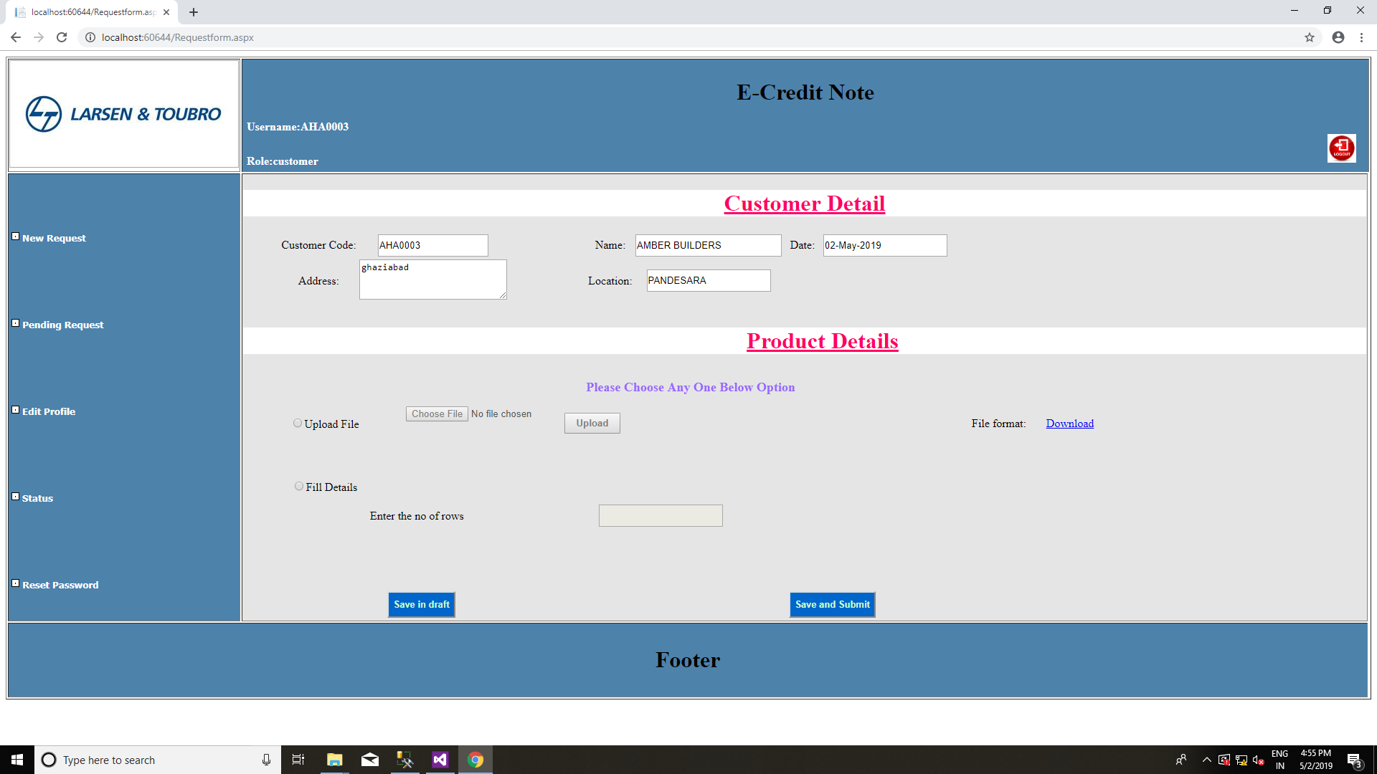
Figure 9 : New Request Form

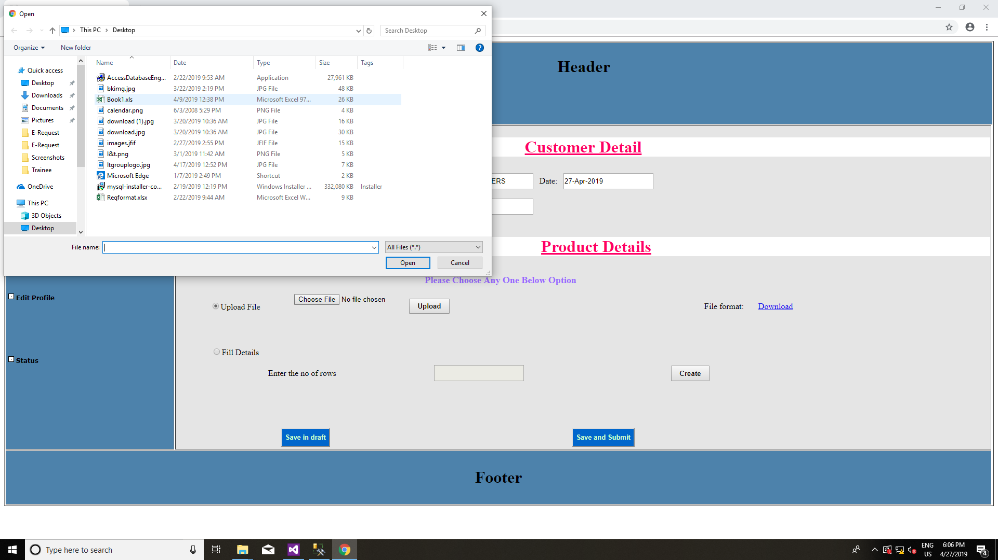
Figure 10 : Customer will upload the excel file
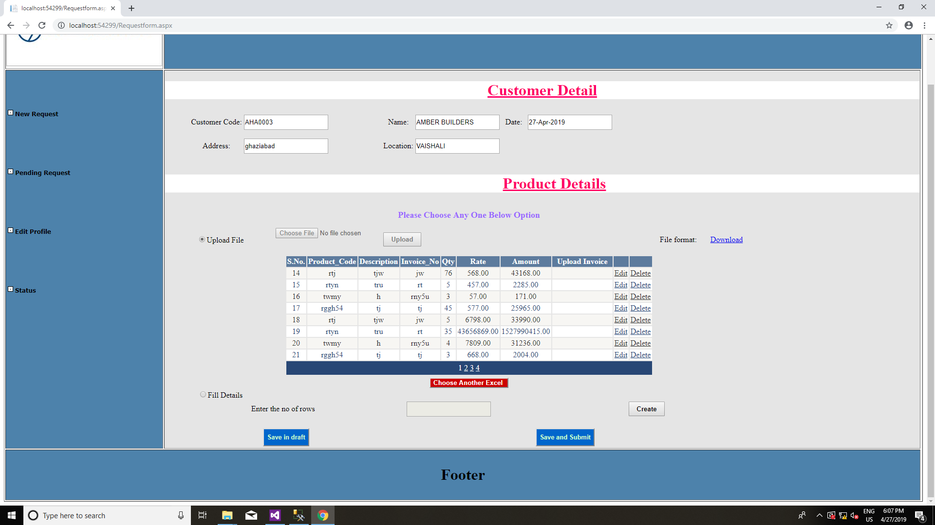
Figure 113 : After Uploading file customer can review

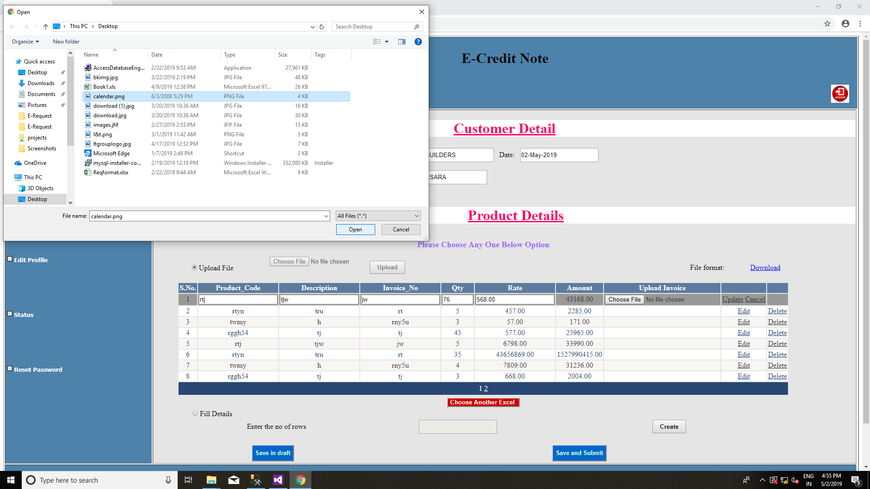
Figure 124 : After Uploading file customer can edit the records and will upload the invoice

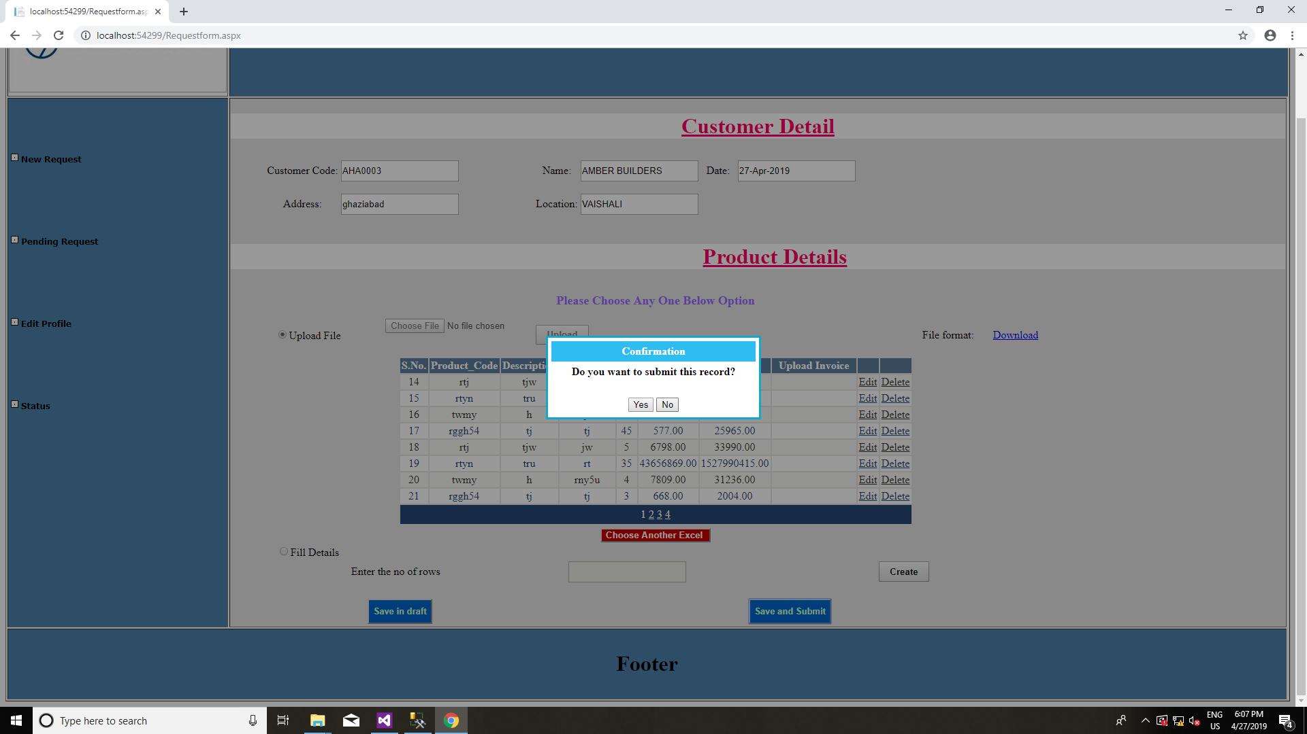
Figure 135 : confirmation popup on submit button click

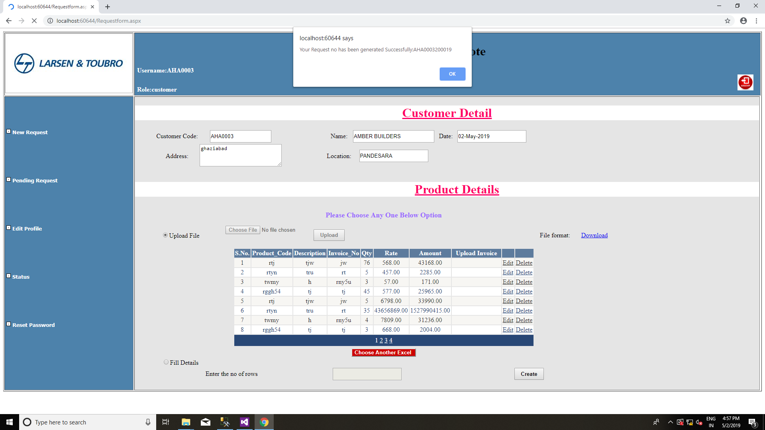
Figure 146 : Alert popup displaying the request no

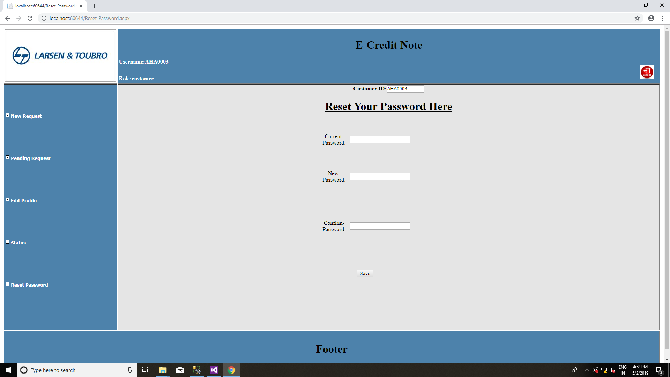
Figure 157 : Checker/Local Authority page

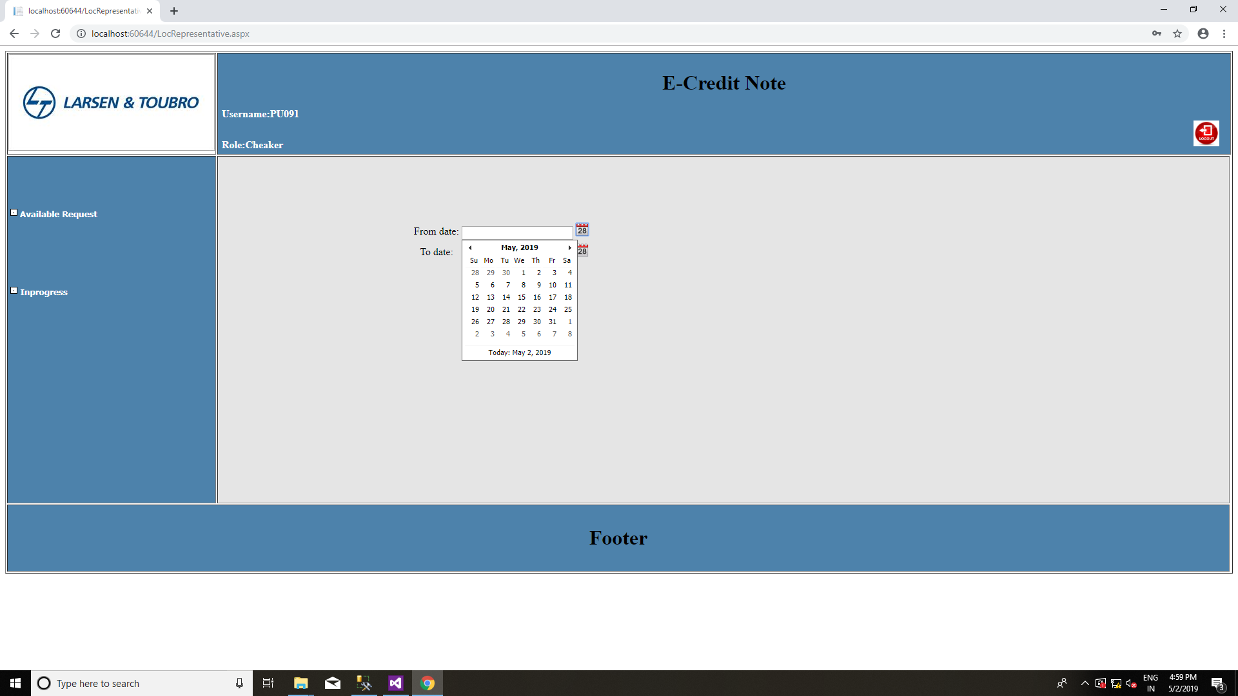
Figure 168 : Checker/Local Authority page

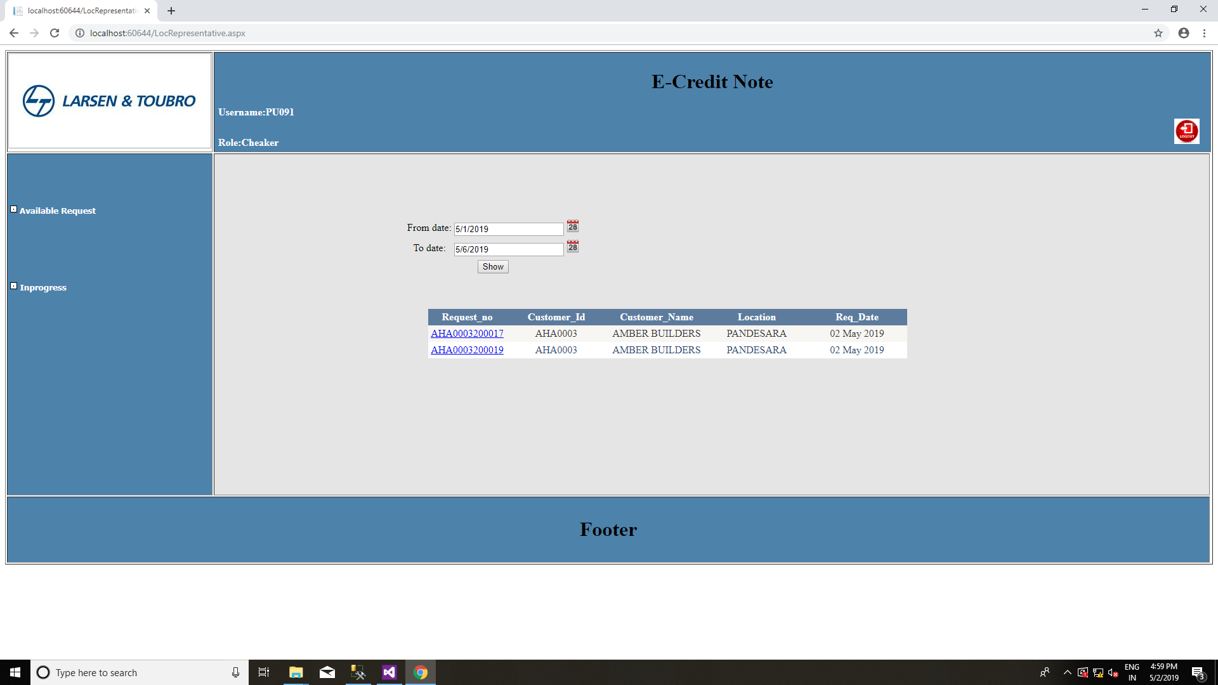
Figure 179 : Filter the request in between dates

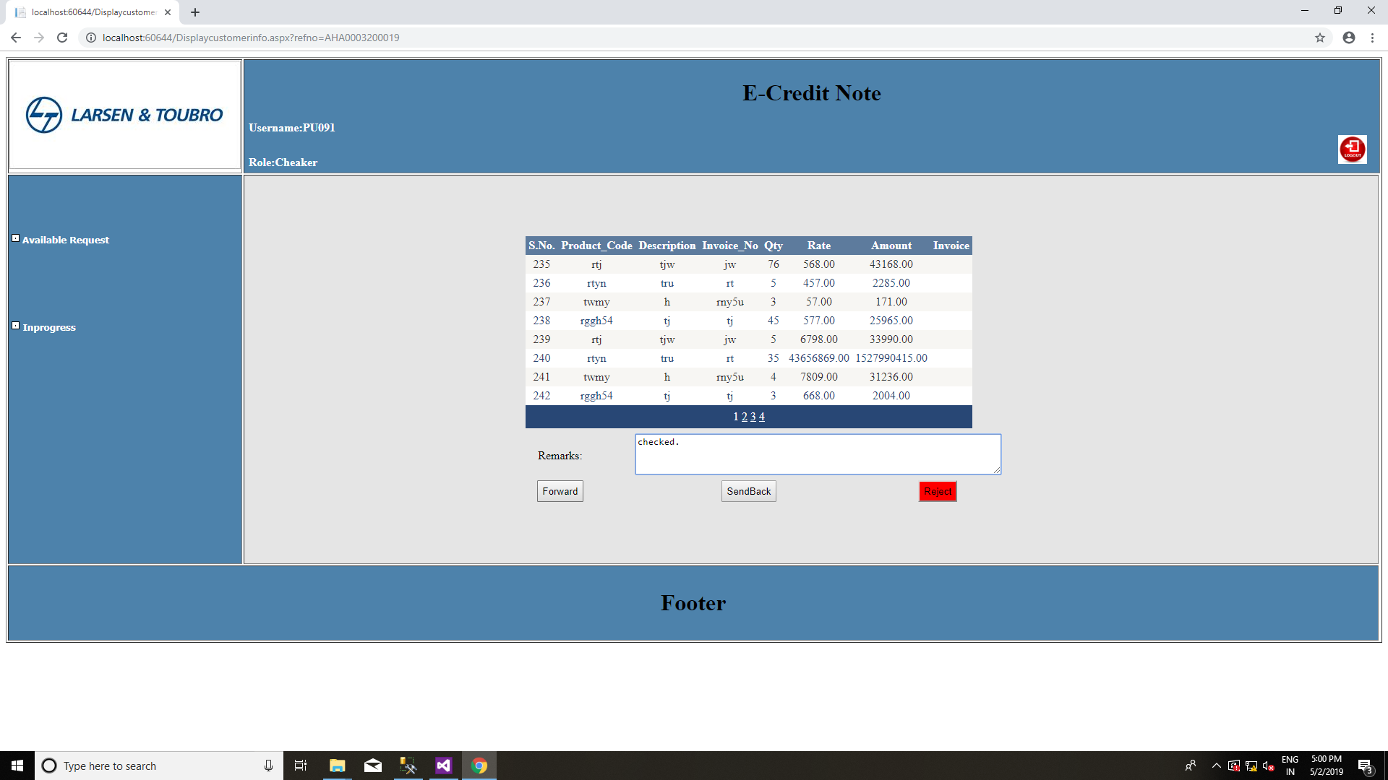
Figure 18: on clicking the req no checker can view the all data and accordingly will checked, send back and reject it.

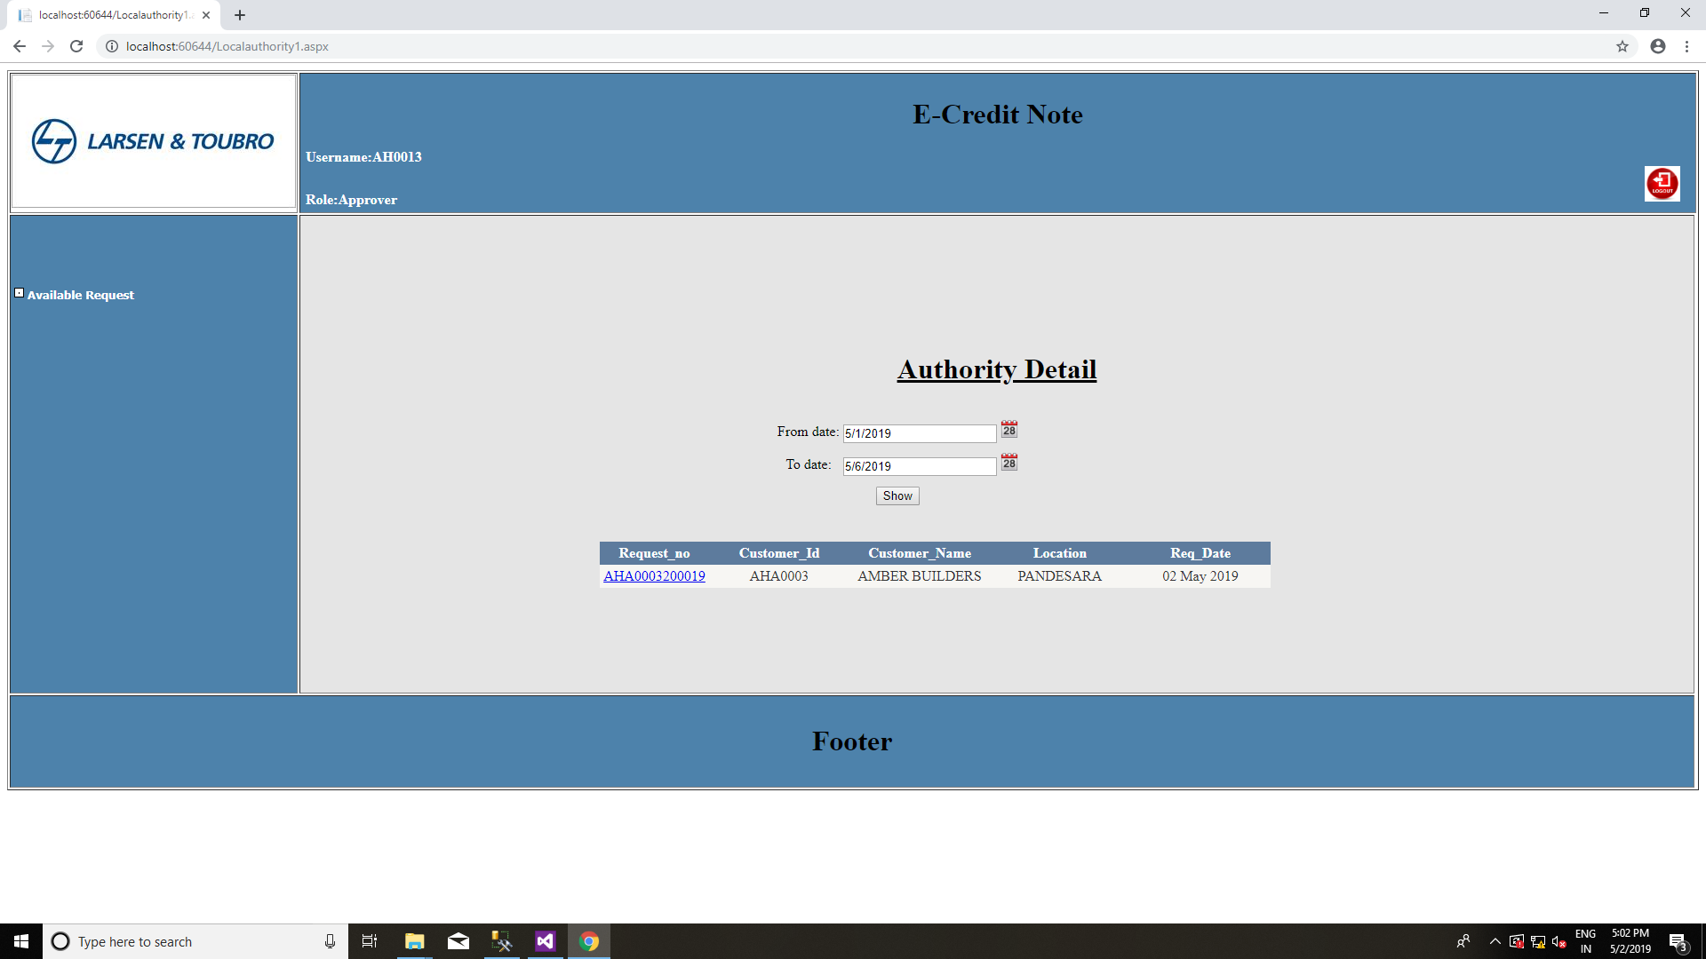
Figure 1910 : Approver will filter the request which has been checked in between dates

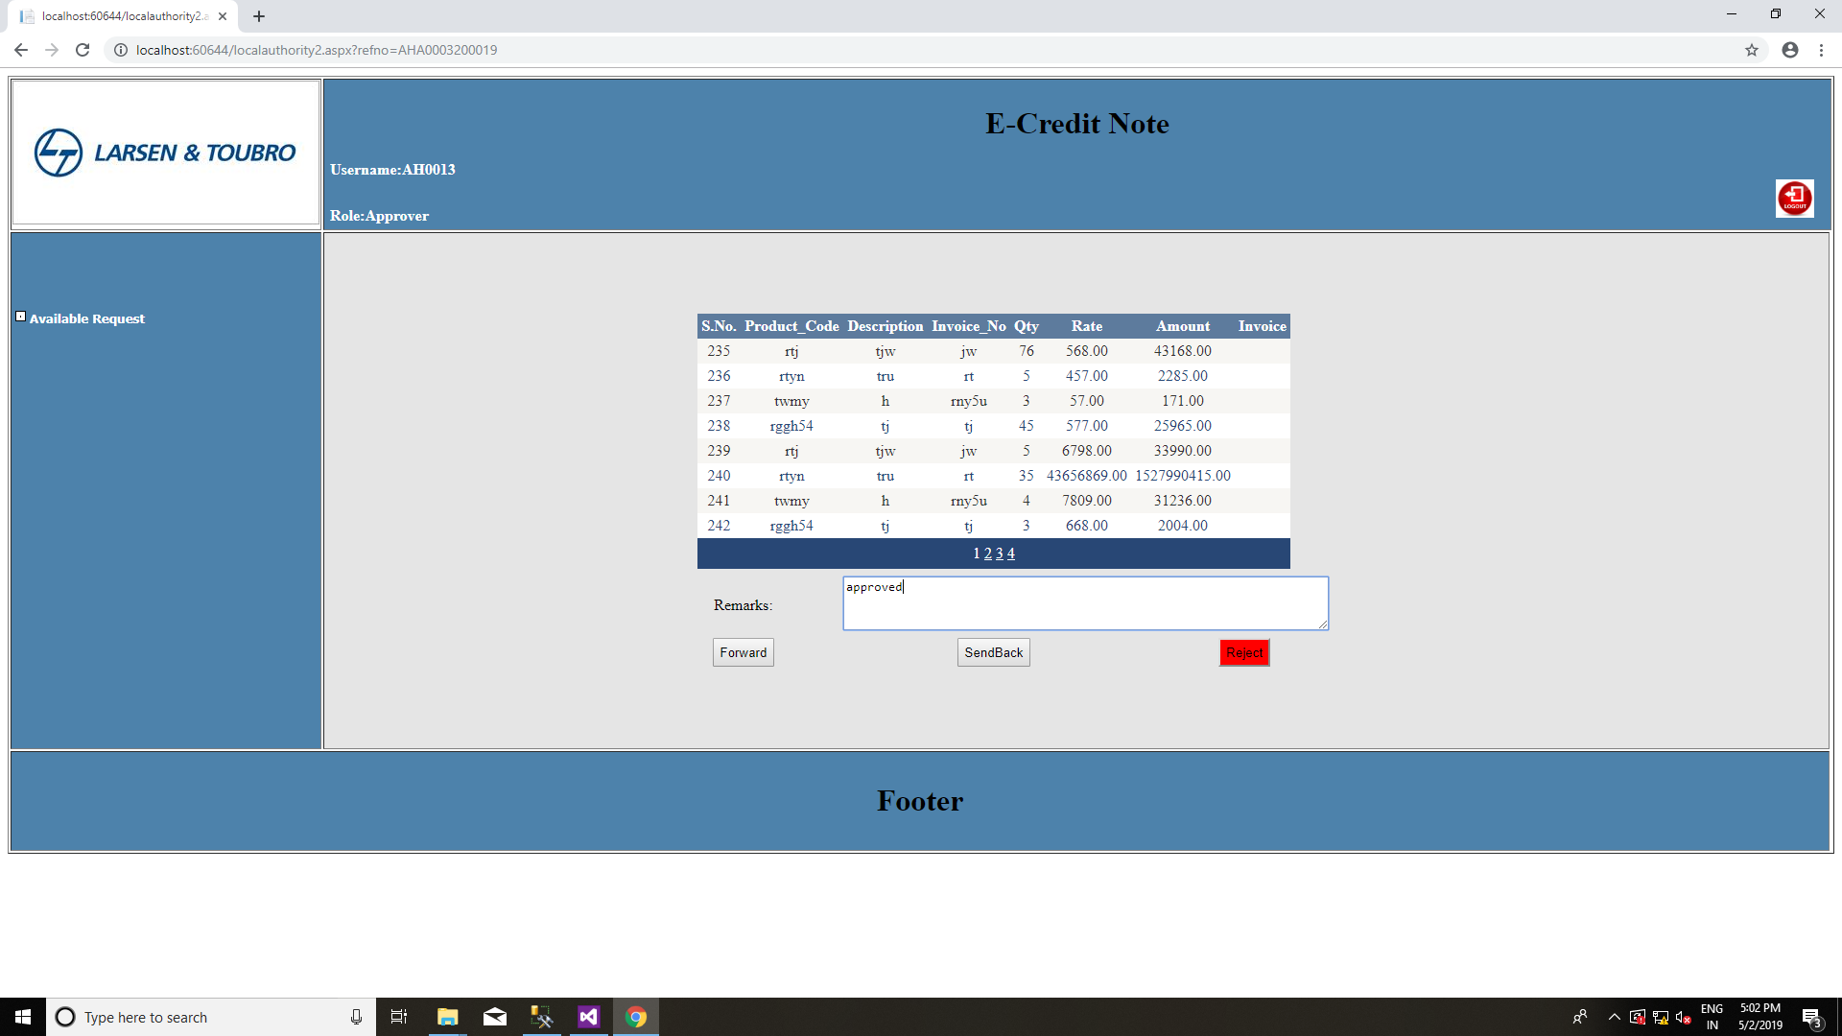
Figure 20: On clicking the request no Approver can view all data and accordingly will approve, send back and reject it.

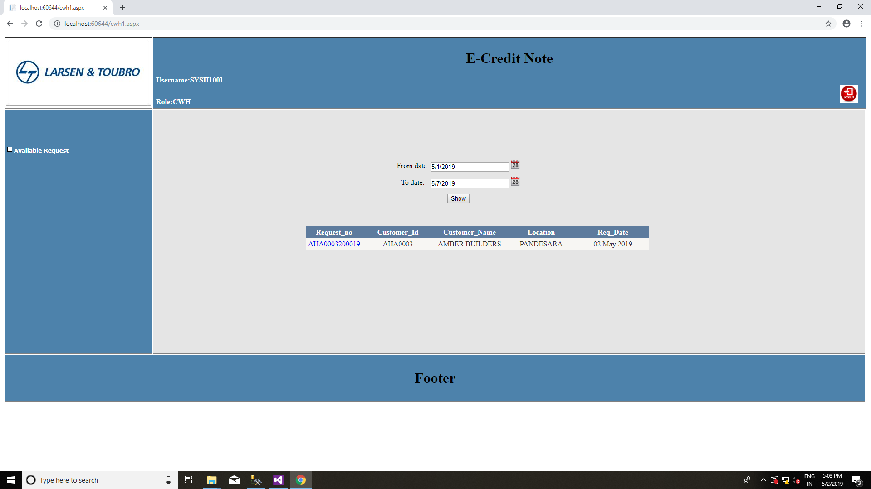
Figure 2111: Finally CWH will verify the request which has been approved by the approver in between dates.

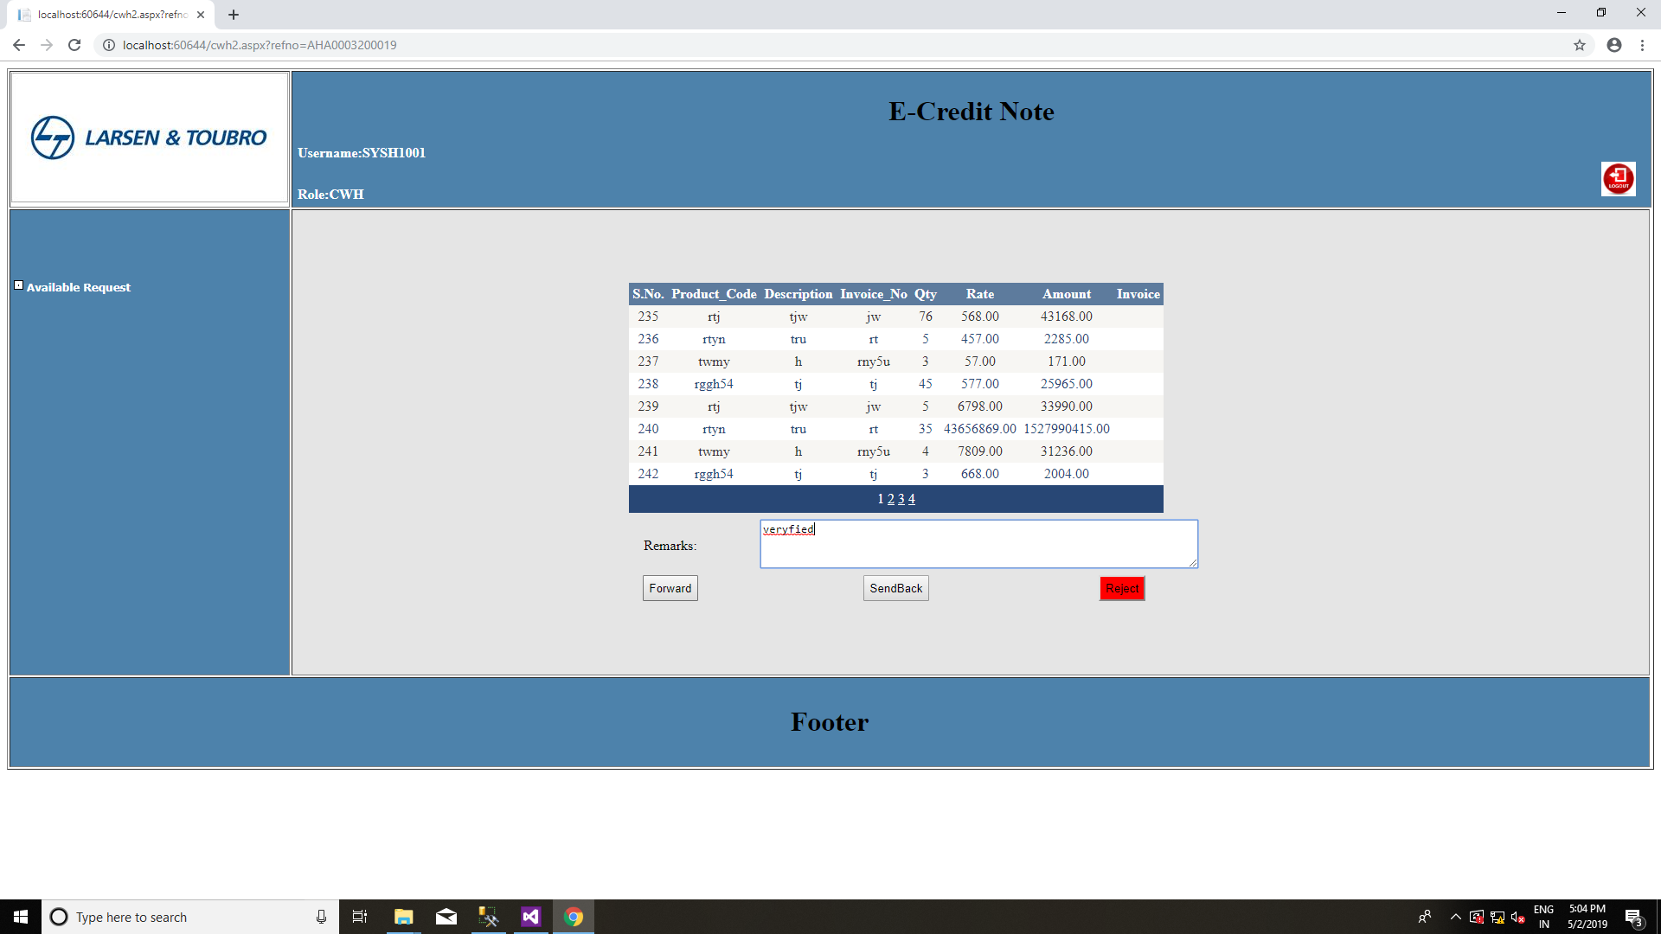
Figure 22 : On clicking the request no CWH can view all data and accordingly will accept, send back and reject it.

CHAPTER – 8

CONCLUSION

8.1. Current state of project
The current status of our project is that all modules like login, home page, add new candidate page, edit details page, view all candidate page of the project are completed and their design, coding and testing are done.

8.2. Remaining areas of concern
There are still, after a lot of efforts, the areas of concern in the project. Once the customer has submitted the request form then he is not able to make any changes. In future we can add this feature to the project.

8.3. Technical and managerial lessons learnt
We have learnt a lot of things while developing the project.
- Working with the Visual studio.
- Working with server-side tasks.
- Style website using JavaScript and asp.net.
- Connect Database with the web application.
- Creating and managing databases using MSSQL server.
- Working in a team and co-ordination among them.
- Problem Analysis and problem solving with the team mates.

8.4. Future scope
In future, This project can be more feasible to the customer/dealer, as the UI will be more attractive, user will be able to track the request and will get notify when their request got rejected or any higher authority send back to the customer/dealer.

Bibliography

[1] https://www.tutorialspoint.com
[2] https://www.aspsnippets.com
[3] https://stackoverflow.com
[4] https://www.c-sharpcorner.com

Reference
- Professional-Visual-Studio-Bruce Johnson
- Professional ASP.NET 2.0-by Bill Evjen (Author), Scott Hanselman (Author), Farhan Muhammad (Author)
- Introducing Microsoft SQL Server 2014, by Ross Mistry,
Stacia Misner

